# Current Environment Description

## Current system description

The goal of this project is to create an instrument capable of learning patterns of improvisation from a selected range of musical input, and then using that new knowledge to play itself live, based on the playing of a human musician.

A neural network consists of an arrangement of nodes or neurons, each of which performs a weighted sum of a sets of inputs and then squashes the result between 0 and 1 using an activation function and adds a constant bias value.

## Current System Overview

|  |  |  |  |  |  |  |
| --- | --- | --- | --- | --- | --- | --- |
| **User** |  | **Channel** |  | **Music Neural Network** |  | **External System** |

**Music Neural Network**

*•*

Find a transformation of data for making a decision

*•*

Approximate functions

*•*

Classification task

Music Composer

Client

Client Relationship

Management system

### High level system overview

|  |  |
| --- | --- |
| **Subsystem** | **Function** |
| **<List the subsystems>** | **<List the functions>** |
| **Neural Network** | * find a transformation of a data for making a decision * approximate functions * classification task |
| **Explanation of what each function does** | * Transformation- The transformation arises from a hierarchical representation learned from the data in order.   -When presenting the network with data that originates from separate distributions (concepts, classes). The hierarchical structure is often critical in  Separating these distributions and preventing overlap.   * Approximates function- There're two characteristics of NNs that distinguish them from others. Neural Networks approximates a function through function composition. The parameters of all component functions are learned from data * It takes an input feature set and selects the best output answer from many possible answers. Case based matching performs the same classification function as well. |

# Current System Hardware, Software and Network

|  |  |
| --- | --- |
| Hardware |  |
| Server Name |  |
| CPU |  |
| Memory |  |
| Hard Disk Storage |  |

System software:

|  |  |
| --- | --- |
| Software | Python |
| Operating System | Linux |
| Application Server Software |  |
| Backup Software | GitHub |

# Volumes and Frequencies

|  |  |  |
| --- | --- | --- |
| Subsystem | Description | Volume and Frequencies |
| <List the subsystems> | <Description of the subsystems> | <Description> |
| Music neural network | * find a transformation of a data for making a decision * approximate functions * classification task | 10 transactions a day |

# CURRENT BUSINESS PROCESS

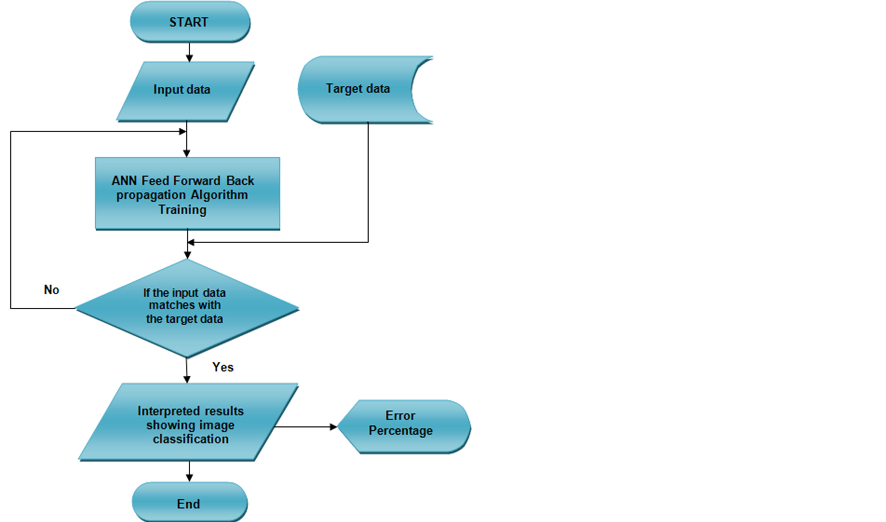

# CURRENT PROBLEMS AND ISSUES

|  |  |
| --- | --- |
| No. | Description |
| <Unique number> | <Description> |
| 1 | Neural networks are not magic hammers |
| 2 | Neural networks are too much of a black box. |
| 3 | Neural networks are not probabilistic |
| 4 | Neural networks are not a substitute for understanding the problem deeply |